How to find a program for a device

1. Please go to the official website of Dahua through the following link：

<https://www.dahuasecurity.com/>



1. Please enter the model of the device you want to get the program from here

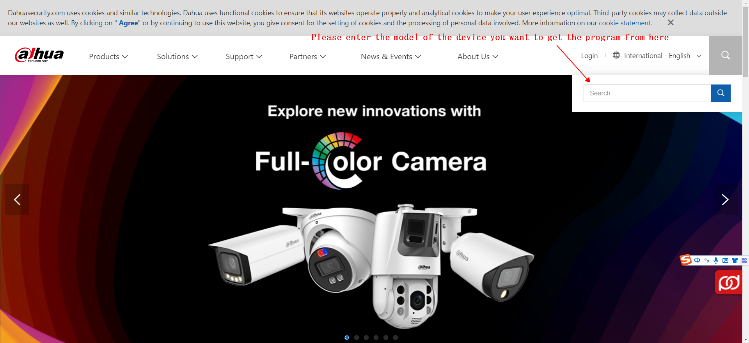

1. Let's take "IPC-HDBW2541E-S" as an example, you need to enter the model number of the program you are looking for in the search bar, then click on 'Firmware' and the latest available programs will be displayed below. Then click on the program to download it

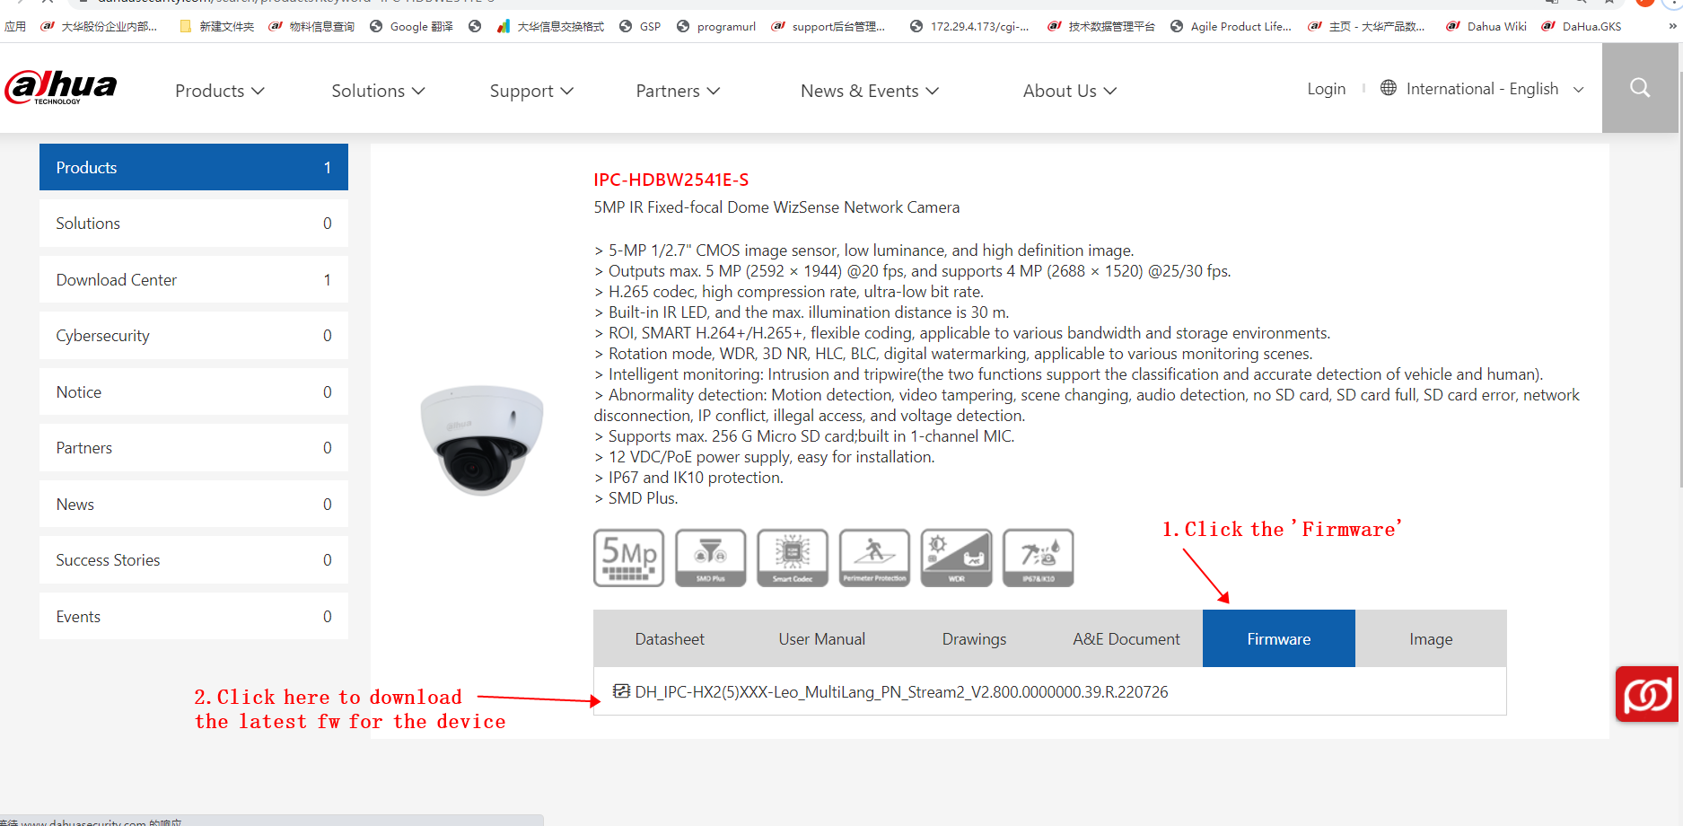

4. You can go to the device web or use the Configtool tool to upgrade the device

The Configtool tool can be downloaded by clicking the following link to enter Dahua's official website

<https://support.dahuasecurity.com/en/tools/desktopSoftware/244/245>

