Matrix and NVD reset password
1.NVD
When the password is forgotten, the device can be reset to the factory by hard reset configuration. The factory reset method of the 2.5U device is that after the device is turned on, press and hold the reset button on the main control until the device restarts and release it, that is, it restores to the factory setting. All other models of decoders can be reset to factory settings by pressing the power switch on the front panel 3 times within 1S. After pressing successfully, the device will automatically restart.

NVD0105/ NVD0405/ NVD0905
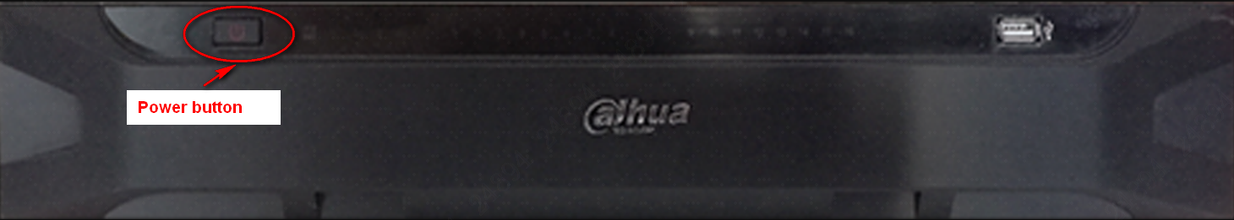

2.5U(NVD01205/ NVD1505/ NVD1805/ NVD2105/)
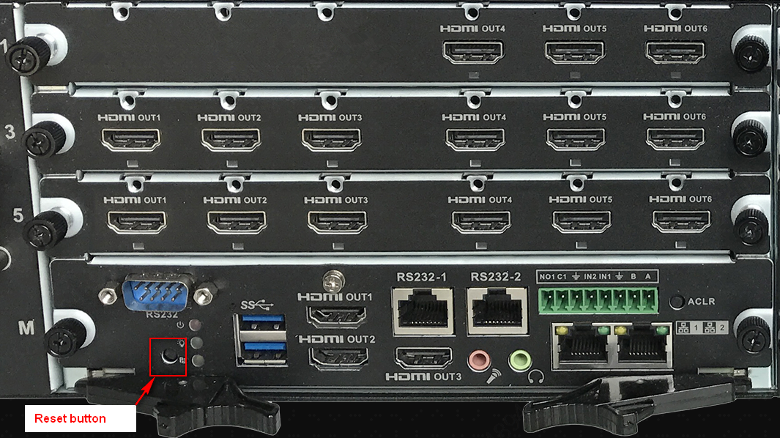

2.Matrix
Hardware clear configuration recovery password, the M70-E main control board has a reset hole on the left, as shown in the number 1 in the figure below, M60 is at the top of the front of the main control board, poke the device with a sharp object for 3-5s, the device will restart, and the device will restart After the password will be restored to the default admin.

M70-E:
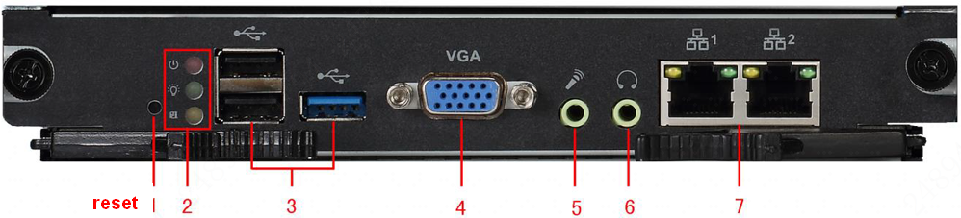

M60:
